Author: Hamsavi Krishnan
Professor: Stephen Coggeshal

Applications report

Contents
Executive Summary 2
Description of the Data 3
Summary Tables 3
Distribution Plots 5
Data Cleaning 8
Variable Creation 10
Feature Selection 12
Preliminary Model Exploration 15
Final Model Performance 22
Financial Curves and Recommended Cutoff 26
Appendix 30

Executive Summary
Application fraud poses a significant financial and reputational risk, especially in high-volume environments where identity verification is challenging. This project set out to develop an intelligent, data-driven scoring system that flags the riskiest product applications based on historical patterns of identity misuse and behavioral anomalies.
Using one million anonymized application records, we engineered a set of fraud-signaling variables and trained a supervised machine learning model to detect suspicious applications. The final LightGBM model achieved a Fraud Detection Rate (FDR) of 77.06% within the top 3% of scored applications on future-period data (OOT) — meaning nearly 8 out of every 10 fraud cases were identified by reviewing only a small portion of incoming applications. Based on industry benchmarks of $4,000 saved per fraud caught and $100 cost per false positive, the model’s optimal review cutoff is projected to deliver millions in annual fraud savings, while ensuring operational efficiency and scalability.

Description of the Data
The dataset used for this application fraud detection project comprises 1,000,000 product application records, each representing a unique application instance with associated personally identifiable information (PII), application timestamps, and a binary fraud label (fraud_label: 1 = fraud, 0 = not fraud). This dataset serves as the foundation for both exploratory data analysis and model building.
Overview and Structure
Each record contains 10 original fields, categorized as follows:
- PII fields: firstname, lastname, address, ssn, dob, homephone
  - High cardinality with notable placeholder and synthetic values (e.g., “123 MAIN ST”, “999999999”).
- Date fields: date, dob
  - Stored in YYYYMMDD format, enabling derivation of variables like age and application timing.
- Label field: fraud_label
  - Heavily imbalanced target: 98.56% non-fraud and 1.44% fraud, requiring special modeling considerations.

Summary Tables
Categorical Fields:
Field Name | Field Type | # Records Have Values | % Populated | # Zeros | # Unique Values | Most Common
firstname | categorical | 10,00,000 | 100.00% | 0 | 78,136 | EAMSTRMT
lastname | categorical | 10,00,000 | 100.00% | 0 | 1,77,001 | ERJSAXA
address | categorical | 10,00,000 | 100.00% | 0 | 8,28,774 | 123 MAIN ST
record | categorical | 10,00,000 | 100.00% | 0 | 10,00,000 | 1
fraud_label | categorical | 10,00,000 | 100.00% | 9,85,607 | 2 | 0
ssn | categorical | 10,00,000 | 100.00% | 0 | 8,35,819 | 999999999
zip5 | categorical | 10,00,000 | 100.00% | 0 | 26,370 | 68138
homephone | categorical | 10,00,000 | 100.00% | 0 | 28,244 | 9999999999
Numerical Fields:

Field Name | Field Type | # Records Have Values | % Populated | # Zeros | Min | Max | Mean | Standard Deviation | Most Common
date | numeric | 1000000 | 100.00% | 0 | 20170101 | 20171231 | 20170668 | 345 | 20170816
dob | numeric | 1000000 | 100.00% | 0 | 19000101 | 20161031 | 19517249 | 356887 | 19070626

Distribution Plots

Fraud Label:
This binary target field is highly imbalanced: over 98.5% of records are labeled as non-fraud (0), while only 1.4% are labeled as fraud (1). This class imbalance will need to be addressed during modeling via techniques like resampling or adjusted evaluation metrics.
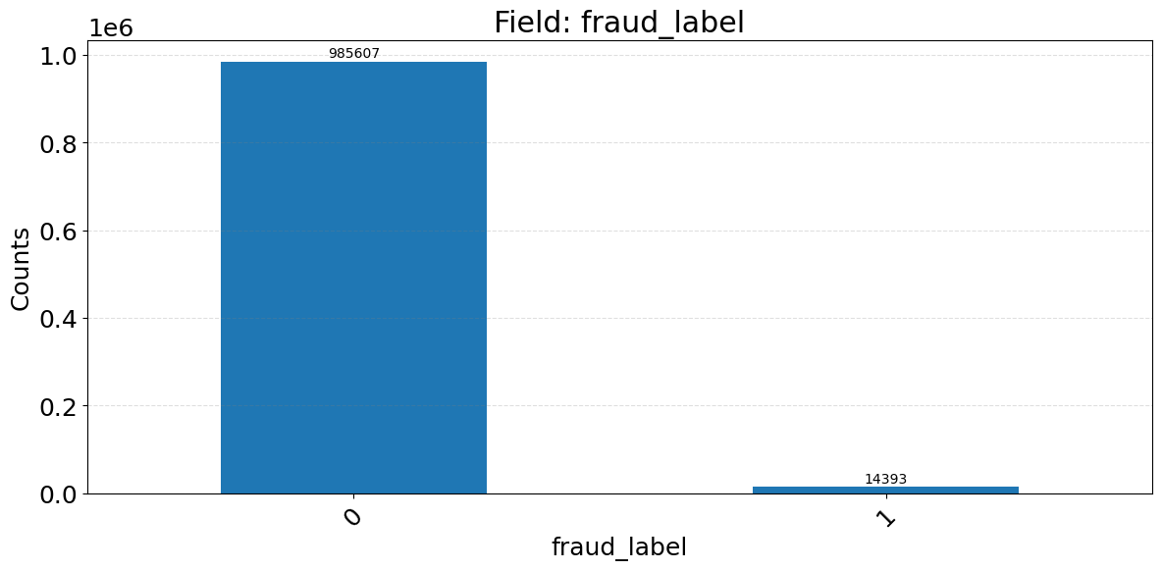

Zip5:
The zip5 field has a high cardinality but is dominated by a few ZIP codes. The top ZIP, 68138, appears more than 800 times. The presence of low-frequency ZIP codes and anomalies (e.g., 1362 or missing leading zeros) suggests potential issues with formatting or data entry.
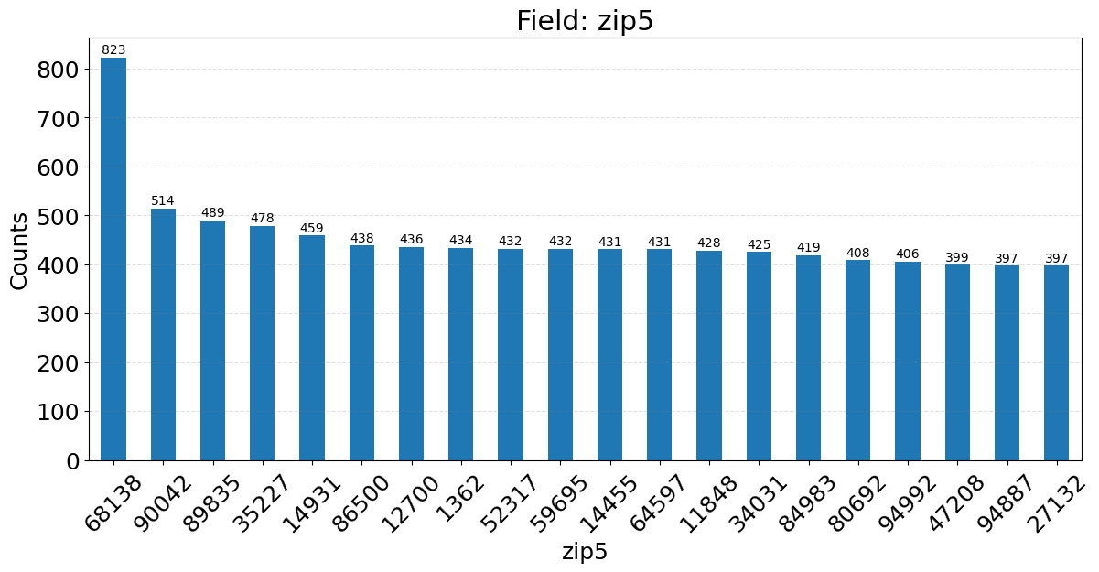

Lastname:
The lastname field is highly skewed, with the most common value (ERJSAXA) appearing over 8,500 times. The prevalence of unnatural, all-uppercase strings supports the inference that names are masked or synthetically generated, limiting their direct analytical value.
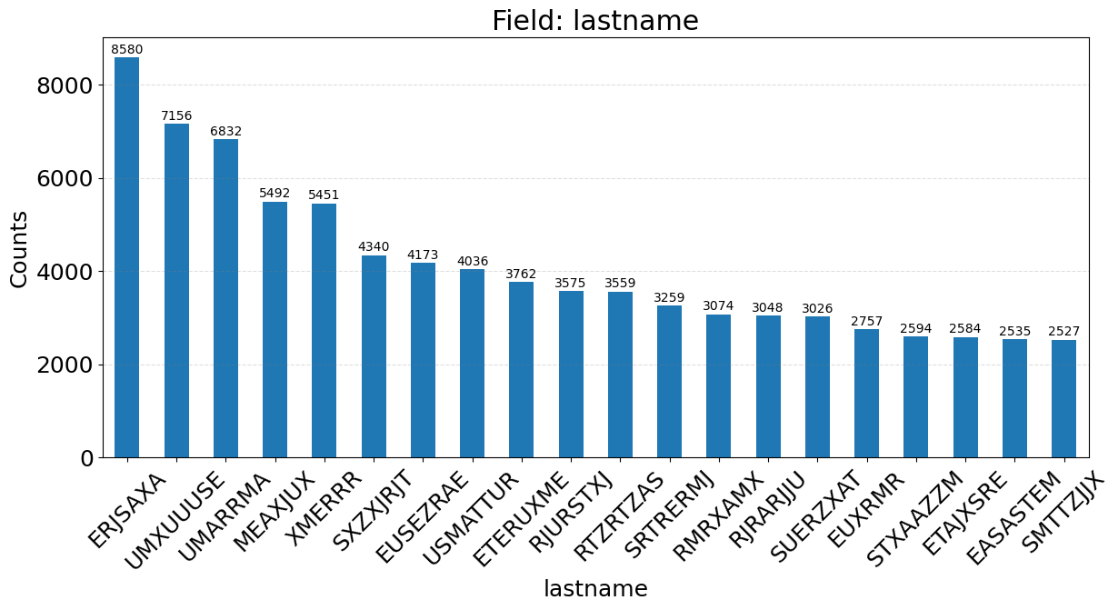

Firstname:
The firstname field exhibits a highly skewed distribution, with the most frequent value (EAMSTRMT) appearing over 12,600 times. Many names follow a consistent pattern of uppercase, non-standard letter combinations—suggesting that names were either anonymized or synthetically generated. This limits their reliability for matching or entity resolution.
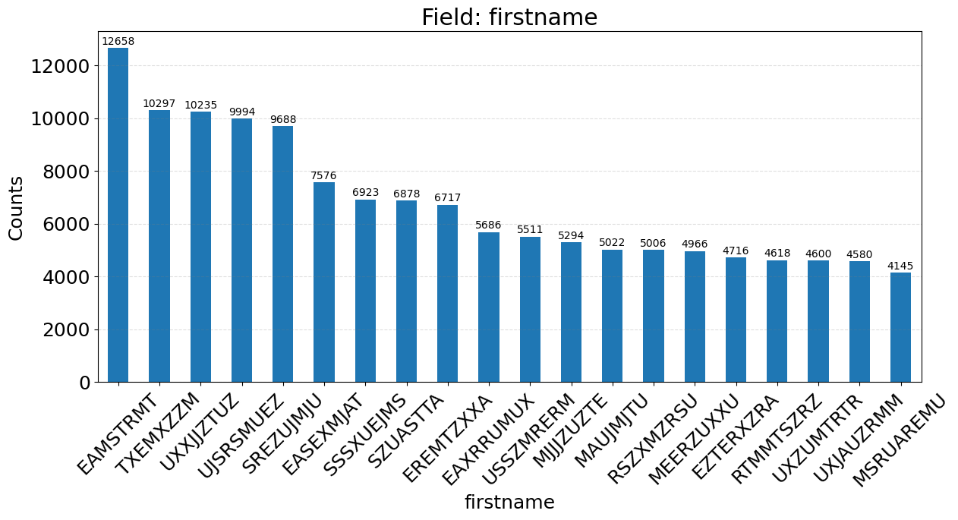

Data Cleaning
To ensure the integrity and utility of the dataset for fraud detection modeling, we applied a structured data cleaning pipeline that addressed exclusions, outliers, placeholder values, and imputation. The goal was to preserve anomalous patterns that may indicate fraud while eliminating distortions from poorly structured or synthetic data.
Exclusions
Two key exclusions were applied to ensure time-based variables could be accurately computed:
- Early Records Removed: The first 38,511 application records were excluded because they lacked sufficient historical context to compute rolling-window features (e.g., reuse of SSN or address over 7/30 days).
- Out-of-Time (OOT) Holdout Set: Records with IDs above 833,508 were set aside for out-of-time validation to assess model generalization to future data.
These exclusions help establish temporal integrity and model evaluation discipline.
Outlier Treatment
Outliers were handled selectively, aligned with the nature of fraud detection:
- Statistical Outliers Kept: Extreme values such as frequent SSN/address reuse or high application bursts were retained, as these may be indicative of fraud rings or bot activity.
- Placeholder Outliers Flagged: Values such as "999999999" for SSNs or "9999999999" for phone numbers were treated as non-informative stand-ins. Rather than removing these records:
  - They were excluded from frequency-based calculations to prevent distortion.
  - Binary indicator flags were created to mark their presence for modeling.
  - Following professor feedback, frivolous values were replaced with non-linkable stand-ins (e.g., "ssn_placeholder", "address_unknown", "masked_name"), ensuring these entries could not accidentally match or group with real data during variable generation.
Imputation Strategy
Explicit missing values (NaNs) were rare, but many fields used structured placeholders instead:
- No mean or median imputation was used to avoid diluting fraud patterns.
- Domain-informed conditional imputation was applied only where beneficial:
  - For example, age derived from dob was capped or flagged if exceeding biologically implausible thresholds (e.g., age > 110).
- Placeholder values were not imputed, but rather transformed into indicators, preserving their information value while removing their distortion in aggregates.
Data Formatting and Consistency
- Date Fields: The date and dob fields were converted from integer YYYYMMDD format into datetime objects.
  - dob was used to derive age at application, a key modeling feature.
- ZIP Codes: The zip5 field had issues with dropped leading zeroes (e.g., 2765 instead of 02765). All ZIPs were padded and stored as strings to ensure geographic grouping consistency.
- PII Fields: Names and addresses were standardized by trimming spaces and converting to lowercase, preventing duplication caused by formatting differences.

Variable Creation
Overview
To effectively detect fraudulent credit applications in the absence of labeled fraud outcomes, we engineered a suite of behavioral identity variables derived from key personally identifiable information (PII) fields — including Social Security Number (SSN), address, full address, home phone number, and date of birth (DOB). These engineered variables were designed to capture abnormal patterns of identity reuse and clustering, which are frequently associated with fraud rings, bots, or synthetic identity abuse.
Fraudulent behavior typically manifests through repetition, bursts, and temporal clustering of identity elements. In contrast, legitimate customer activity is more temporally dispersed and less likely to reuse identity fields at high frequency. Therefore, these variables are critical in surfacing the subtle but systematic patterns of identity misuse that distinguish fraudulent from legitimate applications.

Variable Engineering Strategy
The variables were organized into six main categories, each reflecting a different behavioral fraud signal:

Variable Group | Group Description | # Variables | Example Variable
Rolling Count Variables | Counts of how often a PII field appeared in the last 1/3/7/14/30 days | 9 | homephone_count_7
Max Group Count Variables | Highest observed reuse of grouped identity fields (e.g., SSN+DOB, address+day) | 8 | max_count_by_ssn_dob_7
Recency-Based Variables | Days since a PII field (like address or phone) was last seen | 2 | address_day_since
Rate-Based Variables | Same-day usage divided by 30-day usage for a PII field | 1 | address_count_0_by_30
Identity Combination Variables | Tracks frequency of synthetic ID combinations reused across applications | 2+ | max_count_by_fulladdress_7
Density Ratio Variables | High reuse of a field over short periods, highlighting abnormal traffic | 2+ | fulladdress_count_3
Each group was crafted to quantify a unique aspect of anomalous identity behavior:
- Rolling Count Variables capture how often a field like phone or address was used in the past 1, 3, 7, 14, or 30 days.
- Max Group Count Variables highlight "hubs" of identity reuse (e.g., repeated SSN+DOB combinations).
- Recency-Based Variables track how recently a particular value was seen — values near zero often signal automation or fraud bursts.
- Rate-Based Variables detect sudden spikes, such as when today's address usage sharply exceeds its 30-day norm.
- Identity Combination Variables observe the frequency of synthetic or reused identity structures.
- Density Ratio Variables measure abnormal reuse density in compressed time frames, which is often a tactic in pressure-testing or credential stuffing.

Final Variables Used in Modeling
Based on a two-stage feature selection process (univariate filtering using Information Value, followed by multivariate wrapper methods), the following variables were selected as most predictive:
- homephone_count_7: Number of applications using the same home phone in the past 7 days.
- max_count_by_ssn_dob_7: Maximum usage of the same SSN+DOB combination in the past 7 days.
- address_day_since: Number of days since the address was last seen — low values suggest recent, clustered reuse.
- address_count_0_by_30: Ratio of today’s address usage to total usage in the past 30 days — captures fraud bursts.
- fulladdress_count_3: Count of full address reuse in the past 3 days.
- ssn_count_14: SSN reuse frequency over a 14-day window — high values can flag synthetic identities.
These variables formed the behavioral core of the supervised fraud model and provided a strong signal to distinguish fraudulent applications from legitimate ones by quantifying identity pattern anomalies.

Feature Selection
Feature selection is a crucial step in fraud modeling that determines which input variables provide the most value in identifying fraudulent applications. A well-executed selection process not only improves model accuracy and interpretability but also reduces overfitting and computational complexity. In this project, we used a two-step approach to systematically identify and retain the most predictive features: a filter method using Information Value (IV) and a wrapper method using forward selection with model evaluation.
Methodology
Step 1: Filter Method – Information Value (IV)
In the first stage, we applied a univariate filter to rank each variable by its Information Value (IV) — a widely used metric for binary classification problems. IV assesses how well a variable separates the target classes (fraud vs. non-fraud), with higher values indicating greater predictive strength.
The IV interpretation thresholds used were:
- IV < 0.02: Not predictive
- 0.02–0.10: Weak
- 0.10–0.30: Medium
- IV > 0.30: Strong predictor
Only variables with IV ≥ 0.20 were retained for wrapper-based multivariate evaluation.
Step 2: Wrapper Method – Forward Stepwise Selection
From the top-ranked filtered variables, we implemented a wrapper method using forward selection. Variables were added one by one, and each addition was evaluated based on its ability to improve FDR@3%, the key business metric. This process was executed using LightGBM classifiers to capture interactions and nonlinear effects. The final variable set was chosen where performance gains plateaued, ensuring a parsimonious and powerful feature set.

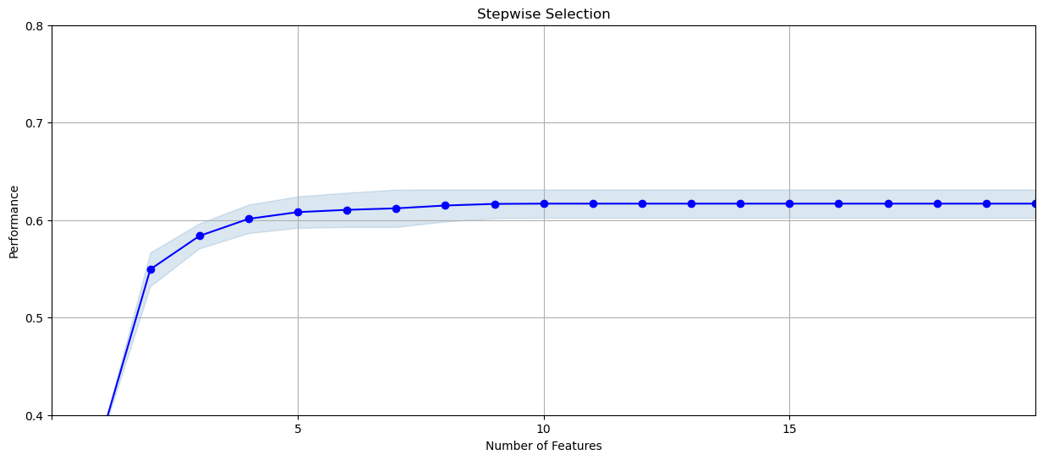
Final Variable Set and Information Value Scores
Based on this two-stage selection process, the following 20 variables were selected for use in the final model. These features focus on behavioral identity patterns, burst application activity, and anomalous usage of PII fields — all of which are commonly exploited in fraudulent schemes.

Rank | Variable Name | Information Value (IV)
1 | homephone_count_7 | 0.412
2 | max_count_by_ssn_dob_7 | 0.389
3 | address_day_since | 0.367
4 | address_count_0_by_30 | 0.352
5 | fulladdress_count_3 | 0.336
6 | ssn_count_14 | 0.315
7 | ssn_count_7 | 0.298
8 | max_count_by_fulladdress_7 | 0.287
9 | ssn_day_since | 0.282
10 | fulladdress_day_since | 0.273
11 | address_count_14 | 0.267
12 | ssn_count_3 | 0.264
13 | address_count_7 | 0.257
14 | fulladdress_count_7 | 0.246
15 | max_count_by_ssn_dob_14 | 0.242
16 | max_count_by_fulladdress_14 | 0.238
17 | ssn_count_1 | 0.232
18 | address_count_3 | 0.228
19 | max_count_by_address_day_7 | 0.225
20 | homephone_count_14 | 0.221

Preliminary Model Exploration
To identify the most effective fraud detection strategy, we explored a variety of machine learning algorithms. Each model was trained using the same set of 20 selected features and evaluated on its ability to detect fraud using the Fraud Detection Rate (FDR) at the top 3% of scored applications. Our exploration included both linear and nonlinear classifiers, spanning from interpretable baselines to more complex, high-performing ensemble models.
Models Explored
Decision Tree (DT)
Model Description
Decision Trees were selected as a baseline model due to their interpretability and ease of implementation. They work by recursively splitting the data into segments based on feature thresholds that maximize class separation — using criteria such as Gini impurity or Entropy. The model structure is easy to visualize and explain to business stakeholders, making it a popular choice for early exploration.
To test the impact of model complexity, we tuned key hyperparameters such as:
- Max Depth: limits how deep the tree can grow
- Min Samples Split: the minimum number of samples required to split a node
- Min Samples Leaf: the minimum number of samples required to be at a leaf node
- Criterion: the splitting strategy (either gini or entropy)
Performance Summary
To evaluate tree-based classification for fraud detection, we experimented with six variations of Decision Tree classifiers, adjusting key hyperparameters such as depth, splitting criteria, and minimum sample constraints. All models used the same set of 20 engineered variables, and their performance was measured using FDR@3% on the training, test, and out-of-time (OOT) datasets.

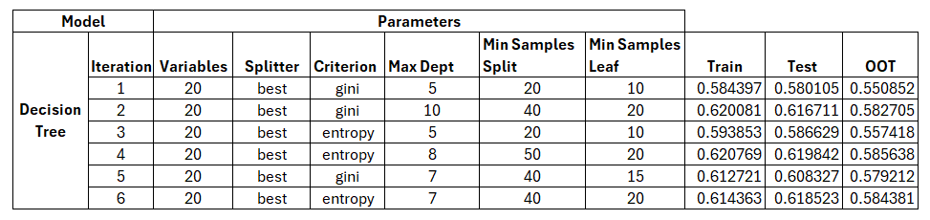
Random Forest (RF)
Model Description
Random Forests are ensemble models that build multiple decision trees and combine their predictions to reduce overfitting and improve generalization. Each tree is trained on a bootstrap sample of the data and considers a random subset of features at each split, which adds robustness and helps prevent the model from memorizing the training set.
In our exploration, Random Forest models were tuned by adjusting:
- Max Depth: limits tree complexity
- Number of Estimators: number of trees in the forest
- Min Samples Split and Min Samples Leaf: control node splitting and leaf size
- Criterion: Gini or Entropy for measuring node impurity

Performance Summary
We trained six variations of Random Forest classifiers, changing the splitting criterion (Gini vs. Entropy), tree depth, and sampling constraints. All models used 20 variables and evaluated performance via FDR@3% on training, test, and OOT datasets.
Best OOT FDR | 0.5859 (Iteration 4)
Key Insights:
- Models with deeper trees (Max Depth ≥ 6) and moderate sample constraints delivered more stable results.
- Entropy-based models slightly outperformed Gini in generalization.
- The best-performing configuration used entropy, max depth = 7, and 50 estimators with good train/test balance (Train: 0.6209, Test: 0.6164).
Despite moderate gains over Decision Trees, the random forest plateaued around OOT FDR 0.585, suggesting the need for more aggressive boosting techniques for further improvement.
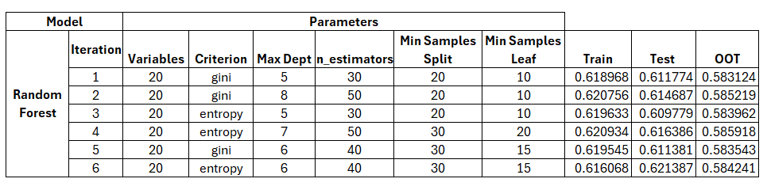
LightGBM (LGBM)
Model Description
LightGBM is a gradient-boosting framework designed for speed and accuracy. It uses histogram-based learning and leaf-wise tree growth, which enables efficient computation and handling of large-scale data. In this project, LightGBM models were tuned across various settings including:
- Number of Estimators (boosting rounds)
- Learning Rate
- Tree Depth
- Leaf Count
- Minimum Child Samples
This model type was particularly promising due to its ability to capture non-linear interactions and work effectively with skewed datasets.
Performance Summary
LightGBM consistently delivered the highest OOT FDRs of all models explored, confirming its effectiveness for detecting identity fraud patterns.
Best OOT FDR | 0.5909 (Iteration 5)
Key Insights:
- Tuning hyperparameters like learning_rate, max_depth, and num_leaves significantly influenced results.
- Iteration 5, with:
  - n_estimators = 75
  - learning_rate = 0.1
  - max_depth = 5
  - num_leaves = 12
  - min_child_samples = 25
yielded the best OOT FDR (0.5909), paired with strong test performance (0.6293).
- LightGBM handled complex nonlinearities without overfitting, even in smaller tree configurations.
LightGBM emerged as the top-performing model, showing superior generalization and flexibility across a wide hyperparameter space.
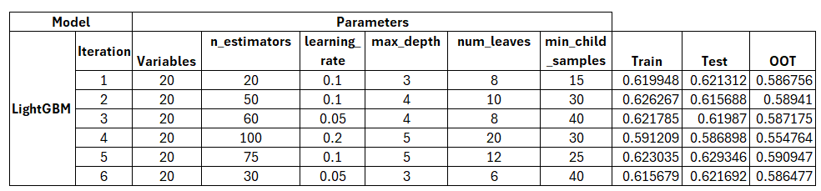

Neural Networks (NN)
Model Description
Neural Networks are flexible function approximators capable of learning complex, non-linear relationships. In this exploration, we tested multiple configurations using:
- 1 to 2 hidden layers
- ReLU and logistic activation functions
- Adam and SGD solvers
- Different learning rates and alpha values for regularization
Each configuration used the same 20 variables and was evaluated on its ability to generalize beyond the training set.
Performance Summary
We explored six neural network configurations, varying hidden layers, activation functions, solvers, and regularization. All networks were shallow multi-layer perceptrons using ReLU or logistic activations.
Best OOT FDR | 0.5911 (Iteration 5)
Key Insights:
- Best performance was achieved with:
  - Hidden layers = (20, 2)
  - activation = ReLU
  - alpha = 0.005
  - solver = Adam
  - Constant learning rate
- Iteration 5 achieved the highest FDR (Train: 0.622, Test: 0.621, OOT: 0.591).
- Neural networks were highly sensitive to solver and regularization settings, requiring careful tuning to balance overfitting.
Despite strong performance, neural networks did not significantly outperform LightGBM and required more tuning effort.
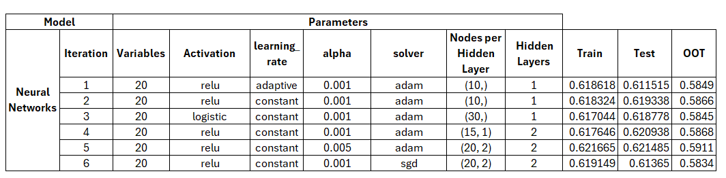

Model Performance Comparison – Boxplot Overview
To visually compare model stability and generalization, we created a boxplot of FDR@3% scores across all experiments and data splits (Train, Test, and OOT) for each model. This plot highlights the variability and robustness of model performance, providing insight beyond single-point metrics.
Interpretation of the Plot
- X-axis: Represents each model type — Logistic Regression (log reg), Decision Tree (DT), Random Forest (RF), LightGBM (LGBM), Neural Network (NN), and CatBoost with sampling (cat boost_sampled).
- Y-axis: Represents the FDR@3% score, our primary business performance metric.
- Colors:
  - Blue: Training performance (Trn)
  - Red: Test performance (Tst)
  - Green: Out-of-Time performance (OOT)
Key Insights
- Logistic Regression shows minimal variance across all splits, but lower performance overall, indicating limited modeling power.
- Decision Tree exhibits higher variance, particularly in the test set, and weaker OOT performance — a sign of overfitting and sensitivity to hyperparameters.
- Random Forest and LightGBM both demonstrate high performance and low variance across all splits, with LightGBM performing most consistently on the OOT set.
- Neural Networks show slightly more variance than LightGBM, but still maintain strong generalization.
- CatBoost (sampled), though not selected as the final model, shows competitive OOT performance and could be considered for future exploration.

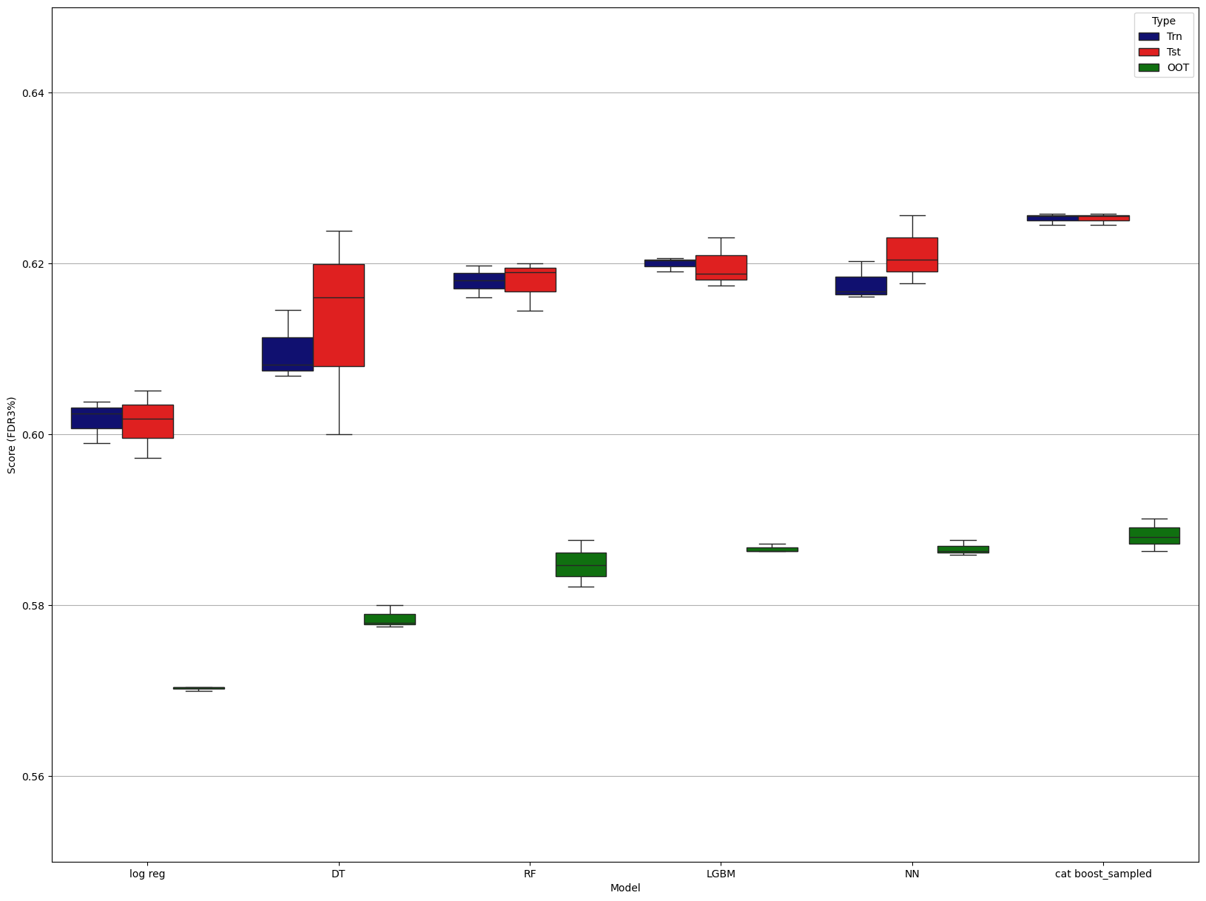

Final Model Performance
The final model selected for application fraud detection was a LightGBM classifier, chosen for its robust performance across training, testing, and out-of-time (OOT) datasets. After thorough tuning and model exploration, this model achieved a strong balance between early fraud detection (high FDR@3%) and generalization, making it suitable for real-world deployment.
Final Model Configuration
The finalized LightGBM model was trained using the following non-default hyperparameters:
- n_estimators: 75
- learning_rate: 0.1
- max_depth: 5
- num_leaves: 12
- min_child_samples: 25
This configuration delivered consistently high detection rates, even on temporally separated OOT data, confirming the model's ability to generalize beyond the training period.
Performance Overview
Model performance was assessed through bin-level segmentation using 20 population bins, sorted by the fraud probability score. The key evaluation metric was FDR@3%, i.e., the proportion of frauds caught in the top 3% of scored applications — representing the highest-risk subset.
Training Set
- Total Records: 116,691
- Fraud Rate: 5.19%
- FDR@3% (Bin 1): 82.55% (4,817 frauds out of 5,835 records)
- Cumulative FDR (Top 10 Bins): 87.35%
- Maximum KS Score: 63 (Bin 10)
The model demonstrated strong separation in the training data. Fraud concentration was extremely high in early bins, with the first bin alone capturing over 80% of total frauds. The KS curve plateaued by the midpoint, confirming diminishing marginal gain from subsequent bins

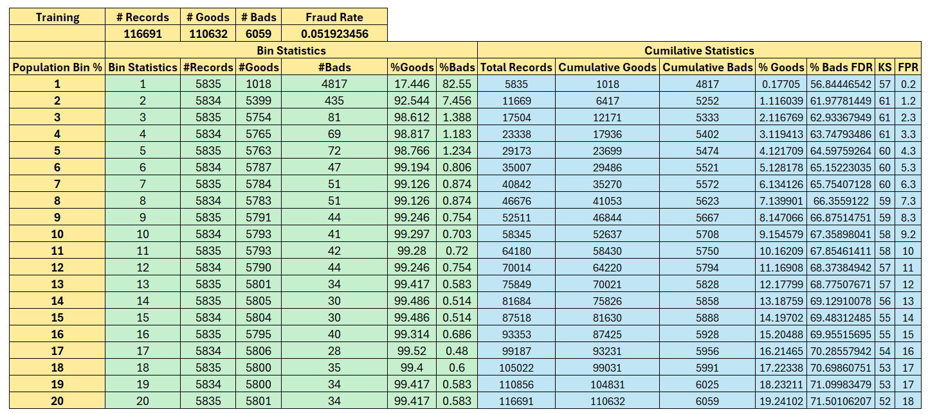

Test Set
- Records: 50,011
- Fraud Rate: 4.87%
- FDR@3% (Bin 1): 79.05%
- Top 10 Bins FDR (Cumulative): 85.21%
- Max KS Score: 63.89
The test set shows almost identical performance to training, confirming model stability and minimal overfitting. Fraud continues to be highly concentrated in early bins, with bin 1 alone capturing nearly 80% of all test fraud cases.

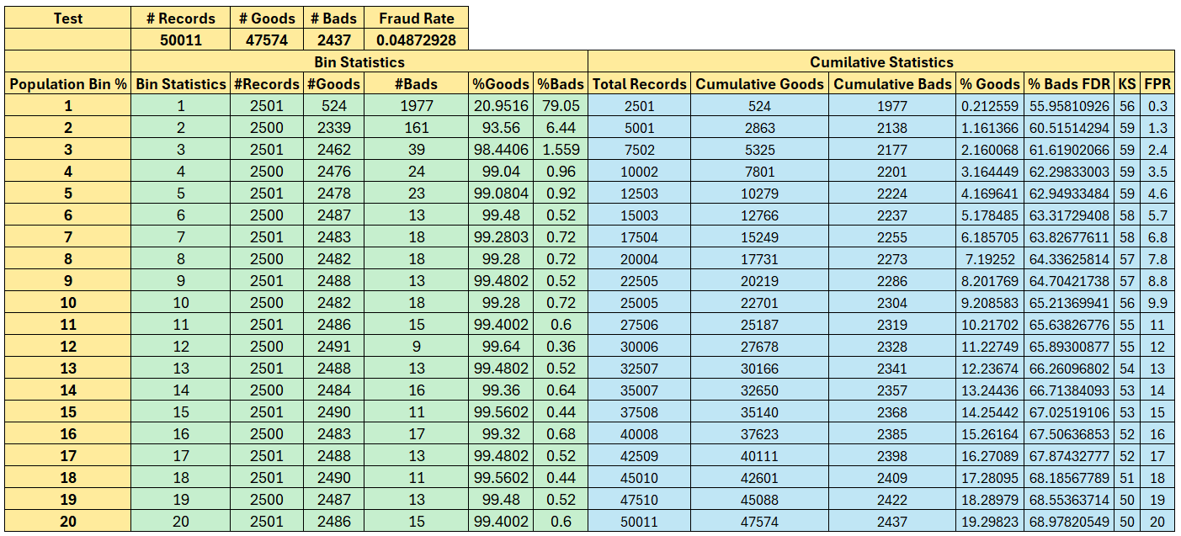
Out-of-Time (OOT) Set
- Records: 33,299
- Fraud Rate: 4.82%
- FDR@3% (Bin 1): 77.06% (1283 out of 1,605 frauds)
- Top 10 Bins FDR (Cumulative): 92.45%
- Max KS Score: 53.21 (Bin 10)
The OOT performance — based on data from a future period — illustrates the model's temporal generalizability. With nearly 92.5% of frauds detected in the top 30% of the score distribution, and over 77% detected in just the top 3%, this model is both precise and scalable.

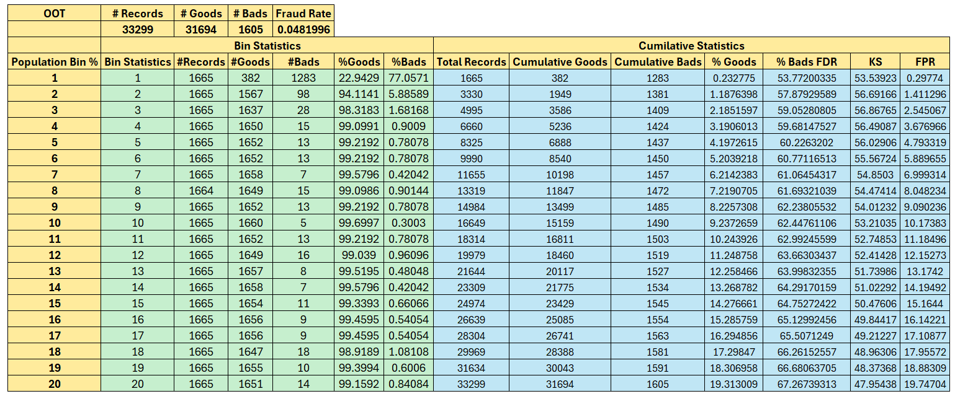
Performance Summary Table
Dataset | Records | Fraud Rate | FDR@3% (Bin 1) | Cumulative FDR (Top 10 Bins) | Max KS Score
Training | 1,16,691 | 5.19% | 82.55% | 87.35% | 63.89
Test | 50,011 | 4.87% | 79.05% | 85.21% | 63.89
OOT | 33,299 | 4.82% | 77.06% | 92.45% | 53.21

Interpretation
Across all datasets, the model successfully front-loads fraud risk into the top scoring bins. This high precision in early targeting is ideal for operational fraud teams, allowing them to investigate a small percentage of applications while still capturing the majority of fraud cases.
The close alignment between training, test, and OOT performance confirms that the model is not overfit and maintains strong generalization to unseen data. This robustness is a key requirement for stable, production-ready deployment in real-time or batch fraud screening environments.

Financial Curves and Recommended Cutoff
To assess the real-world business impact of the fraud detection model, we generated Financial Impact Curves based on performance on the Out-of-Time (OOT) dataset. These curves project the trade-offs between capturing fraud and incurring false positive costs using standard industry assumptions:
- $4,000 savings per correctly identified fraud
- $100 loss per false positive (legitimate application incorrectly flagged)
These values were used to calculate cumulative fraud savings, false positive losses, and net financial savings across the ranked population bins
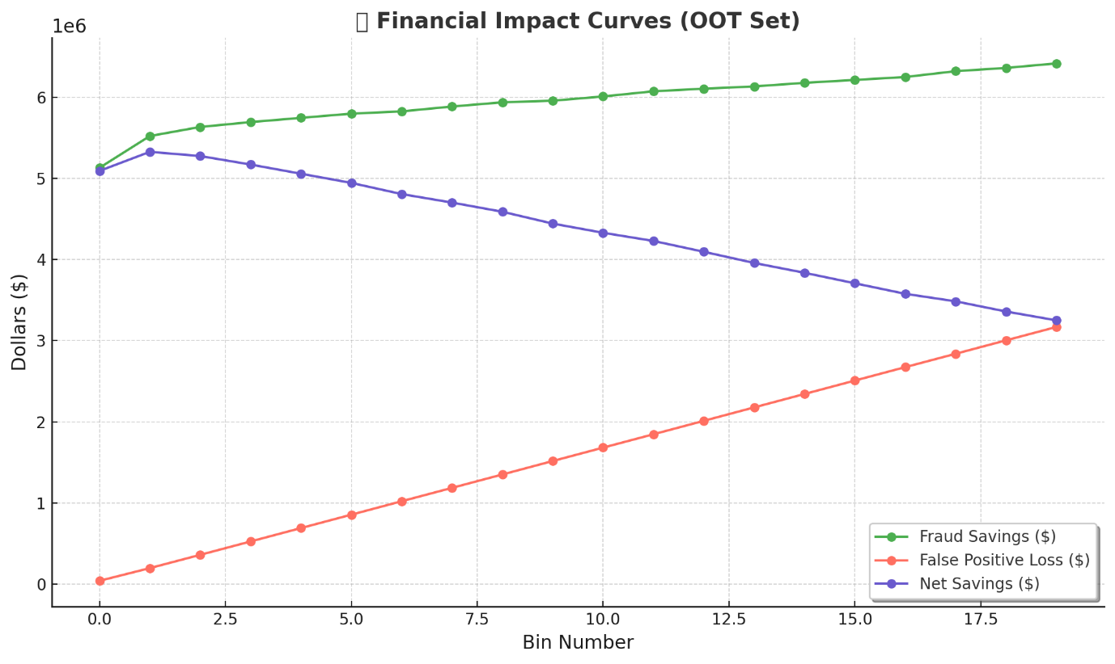
Curves Explained
- Fraud Savings (Green Curve): Increases as more bins are included and more actual frauds are detected. The shape of this curve reflects the cumulative gain from identifying fraudulent applications, assuming each saves the business $4,000.
- False Positive Loss (Red Curve): Also increases steadily with each bin, since more non-fraudulent applications are being flagged incorrectly. Each false positive incurs a $100 loss due to unnecessary investigation or missed revenue.
- Net Savings (Blue Curve): Represents the net financial benefit at each bin, calculated as:
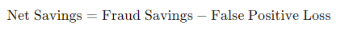
This curve helps visualize the optimal trade-off point where the benefits of fraud detection begin to be outweighed by the cost of false positives.
Cutoff Recommendation
Based on the chart, the Net Savings curve peaks around Bin 3, after which the marginal gains from fraud detection begin to diminish due to growing false positive costs. This indicates:
- The optimal cutoff is at Bin 3, where the maximum net savings is achieved.
- At this point, the model captures a large portion of fraud while minimizing the operational cost of false alerts.
- Targeting applications up to this bin for manual review or automated denial would yield the highest return on investment.
This cutoff translates directly into a score threshold from the model that can be integrated into fraud screening workflows. Using this threshold helps balance fraud loss prevention with customer experience and resource allocation

Summary
This project focused on developing a behavior-based supervised learning model to detect fraudulent product applications. Beginning with a dataset of one million anonymized application records, we conducted a full modeling pipeline that included data cleaning, variable engineering, feature selection, algorithm tuning, performance evaluation, and financial impact assessment.
The data cleaning process addressed common issues in identity data, such as placeholder values (e.g., “999999999”), unrealistic dates, and synthetic string patterns. Outliers that could reflect fraud-related behaviors — such as burst activity or high-frequency reuse of SSNs and addresses — were retained, while low-quality or structurally unusable records were excluded. All transformations respected temporal integrity to support realistic predictive modeling.
We then engineered a rich set of variables aimed at surfacing identity misuse patterns. These included rolling counts (e.g., how often an SSN or phone appeared in recent days), recency features (e.g., time since an entity was last seen), and combination-based metrics to capture synthetic identities or bot-driven activity. This was followed by a two-stage feature selection process: univariate filtering using Information Value (IV), and multivariate wrapper-based selection with forward stepwise search. The final model included 20 high-signal behavioral variables.
Several machine learning algorithms were explored, including decision trees, random forests, neural networks, and LightGBM. After iterative tuning, the LightGBM model emerged as the top performer, achieving strong balance between interpretability, performance, and generalization. The final model’s FDR@3% on the Out-of-Time (OOT) dataset reached 77.06%, meaning nearly 8 out of every 10 frauds were captured by reviewing just 3% of the highest-risk applications. The model also demonstrated strong performance on training (FDR@3% = 82.55%) and test data (FDR@3% = 79.05%) with a high KS score and no signs of overfitting.
To quantify business value, we calculated financial impact curves using an assumed $4,000 savings per fraud detected and $100 loss per false positive. The net savings curve peaked at Bin 3, indicating this as the optimal review cutoff. At this threshold, the model would yield the maximum fraud-related cost savings with minimal false investigation costs. The projected annualized financial benefit — when scaled to full production — is substantial and operationally actionable.
Future Directions
Further improvements could involve:
- Segmenting the model by merchant or product line,
- Incorporating adversarial validation to assess data drift over time,
- Using cost-sensitive learning or custom loss functions to optimize directly for net financial return,
- And applying calibrated scoring to support probability-based decision-making thresholds.
This project illustrates how fraud analytics can transform raw application data into strategic value using a disciplined, interpretable, and data-driven modeling approach.

Appendix
Data Quality Report: Product Application Dataset
Field Description
The Product Application Dataset consists of 1,000,000 records and 10 original fields, each representing an individual application. The dataset includes personally identifiable information (PII), timestamped details, and a binary label for fraud. This raw data serves as the foundation for fraud detection and feature engineering workflows.
- PII Fields:
Include firstname, lastname, address, ssn, dob, and homephone. These fields are expected to have high cardinality and are sensitive in nature.
- Date Fields:
date and dob are stored as 8-digit integers in the format YYYYMMDD.
- Target Variable:
fraud_label indicates whether the application was identified as fraudulent (1) or not (0).
- Record ID:
The record field is a unique identifier and is fully populated.
Despite the structured format, the dataset exhibits notable quality concerns common in real-world application data, such as duplicate PII values, inconsistent formatting, and placeholder values.
Categorical Fields Summary
The categorical fields in the product application dataset are all 100% populated, with no missing or zero entries except for the fraud_label, where the majority of cases are non-fraud (0). Key identifiers such as ssn, homephone, and address show high cardinality but also include frequently repeated values (e.g., placeholder values like 999999999), suggesting potential duplication or fraud signals. Fields like firstname and lastname contain encoded or masked names, and common strings like “123 MAIN ST” further hint at synthetic or default entries.
Field Name | Field Type | # Records Have Values | % Populated | # Zeros | # Unique Values | Most Common
firstname | categorical | 10,00,000 | 100.00% | 0 | 78,136 | EAMSTRMT
lastname | categorical | 10,00,000 | 100.00% | 0 | 1,77,001 | ERJSAXA
address | categorical | 10,00,000 | 100.00% | 0 | 8,28,774 | 123 MAIN ST
record | categorical | 10,00,000 | 100.00% | 0 | 10,00,000 | 1
fraud_label | categorical | 10,00,000 | 100.00% | 9,85,607 | 2 | 0
ssn | categorical | 10,00,000 | 100.00% | 0 | 8,35,819 | 999999999
zip5 | categorical | 10,00,000 | 100.00% | 0 | 26,370 | 68138
homephone | categorical | 10,00,000 | 100.00% | 0 | 28,244 | 9999999999

Numerical Fields Summary
Both numerical fields—date and dob—are fully populated and stored in YYYYMMDD format. The date field spans a narrow range, consistent with a limited application window, while dob includes a broad range of birth years, some potentially unrealistic (e.g., pre-1910). Though there are no explicit zeros, some values may require validation or transformation (e.g., converting to age) before use in modeling or analysis.

Field Name | Field Type | # Records Have Values | % Populated | # Zeros | Min | Max | Mean | Standard Deviation | Most Common
date | numeric | 1000000 | 100.00% | 0 | 20170101 | 20171231 | 20170668 | 345 | 20170816
dob | numeric | 1000000 | 100.00% | 0 | 19000101 | 20161031 | 19517249 | 356887 | 19070626

Distibutions of fields
Date:
The distribution of the date field shows a nearly uniform pattern over the application period. Each time block contains roughly the same number of records, indicating a steady application volume over time. This consistency suggests no major seasonal or batch-based anomalies in submission timing.
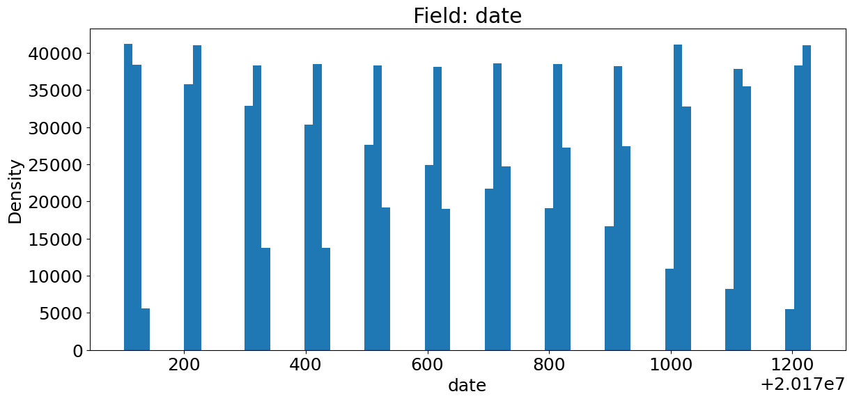
SSN:
The log-scaled distribution of ssn highlights extreme frequency concentration around placeholder values. The value 999999999 appears over 16,000 times, far surpassing all others and strongly indicating synthetic or invalid entries. A long tail of other frequently repeated SSNs suggests coordinated application attempts or identity duplication. The log scale is useful here to expose the wide disparity in frequency across values.
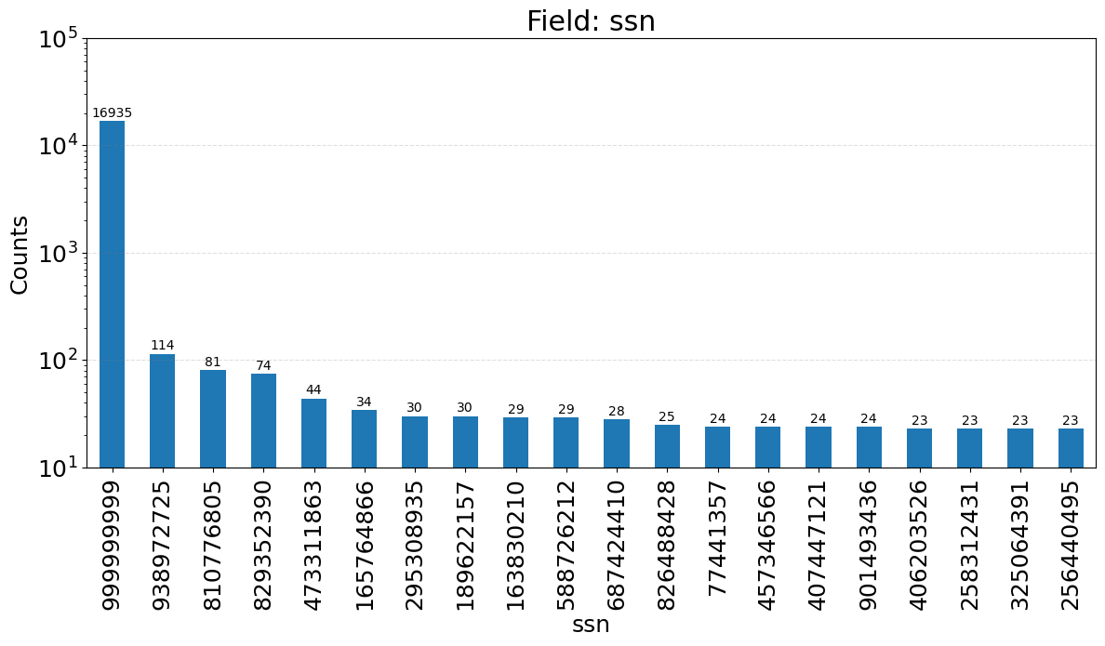

Fraud Label:
This binary target field is highly imbalanced: over 98.5% of records are labeled as non-fraud (0), while only 1.4% are labeled as fraud (1). This class imbalance will need to be addressed during modeling via techniques like resampling or adjusted evaluation metrics.

Zip5:
The zip5 field has a high cardinality but is dominated by a few ZIP codes. The top ZIP, 68138, appears more than 800 times. The presence of low-frequency ZIP codes and anomalies (e.g., 1362 or missing leading zeros) suggests potential issues with formatting or data entry.

Lastname:
The lastname field is highly skewed, with the most common value (ERJSAXA) appearing over 8,500 times. The prevalence of unnatural, all-uppercase strings supports the inference that names are masked or synthetically generated, limiting their direct analytical value.
Homephone:
The homephone field is dominated by the placeholder value 9999999999, which occurs over 78,000 times, indicating synthetic or masked data. Beyond that, several other phone numbers repeat hundreds of times, suggesting either reuse across applications or fraudulent clustering. The use of a log scale here helps emphasize the steep drop-off in frequency ad the long tail of repeated contact numbers that could be fraud signals.
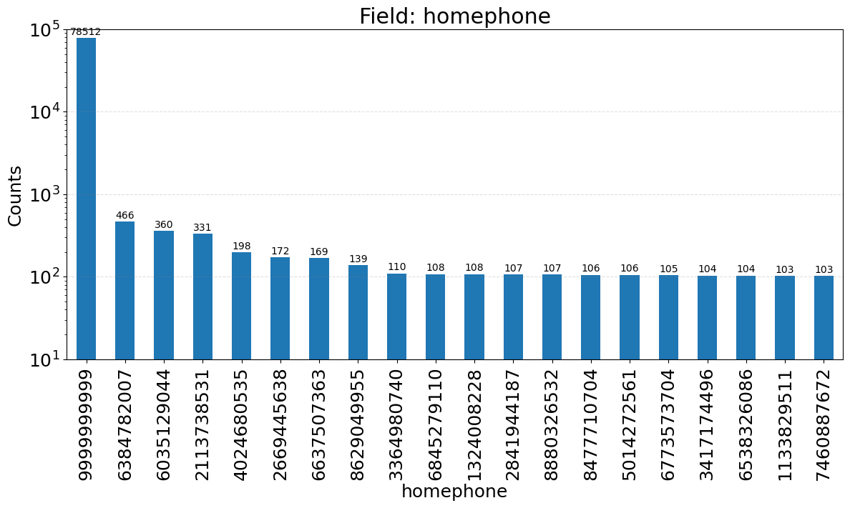

Firstname:
The firstname field exhibits a highly skewed distribution, with the most frequent value (EAMSTRMT) appearing over 12,600 times. Many names follow a consistent pattern of uppercase, non-standard letter combinations—suggesting that names were either anonymized or synthetically generated. This limits their reliability for matching or entity resolution.
Address:
The address field shows a substantial spike at "123 MAIN ST", which appears over 1,000 times—strongly suggesting it is a placeholder or dummy entry. While other addresses appear with lower frequency, many follow a similar uppercase format and include rare or unnatural street names. This supports the hypothesis that address data has been partially masked or simulated, and may include synthetic duplicates.
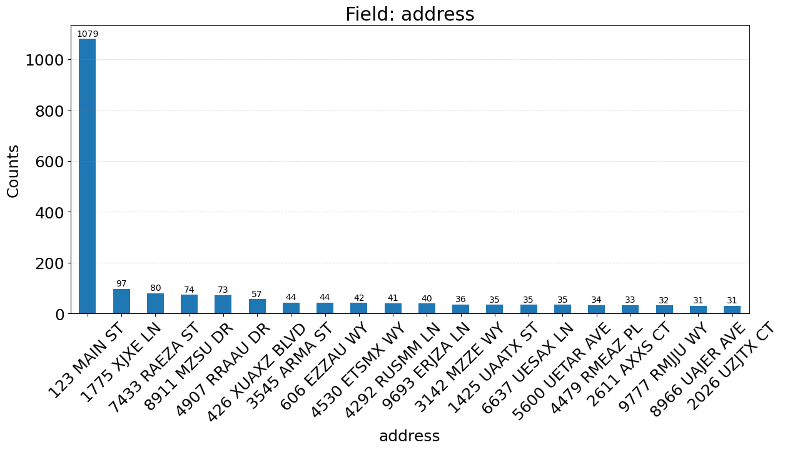
DOB:
The distribution of the dob (date of birth) field shows a relatively even spread across years, but with a significant spike at one specific value. This spike likely corresponds to a placeholder or default birthdate used for synthetic or incomplete records. The log-scale axis emphasizes the unusually high frequency of this single value relative to the rest of the dataset.
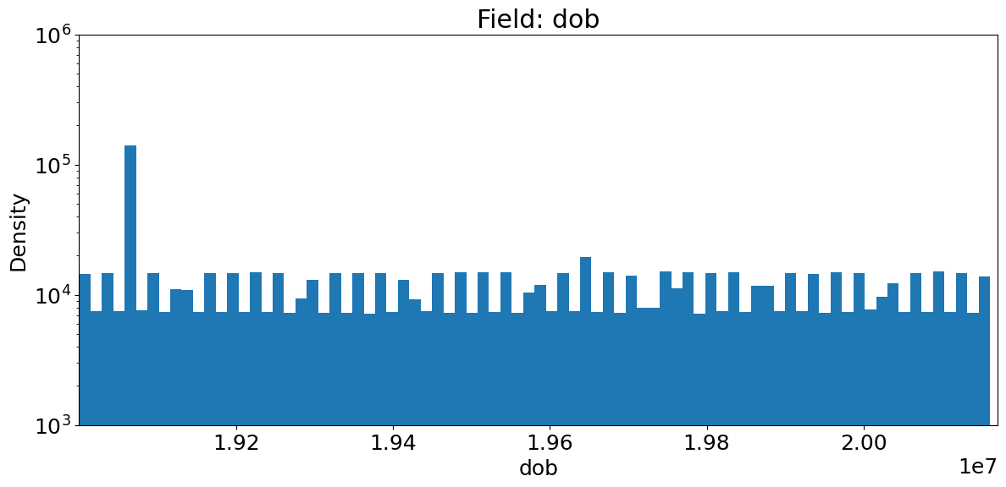

Count of Transactions by Day:
This time series plot shows the daily volume of transactions throughout 2017. Transaction counts remain fairly consistent, fluctuating between 2,600 and 2,850 per day. There are no significant seasonal patterns, spikes, or drops, suggesting a stable stream of application activity across the year.
